PRIMARY THREE
LITERACY II
LESSON NOTES
FOR
TERM ONE (2013)

COMPILED BY;
- ALEX MUTOTO
- ROBERTSON WANZU
- BETTY AKELLO
- ISAAC BUYUNGO
- FLORENCE NAMAGEMBE

WEEK:2 Lesson1&2
THEME 1: OUR SUB-COUNTY/ DIVISION

1. The name of our division is Makindye.
2. Makindye division is one of the five divisions of Kampala district.
3. It is found in the southern part of Kampala district.
4. Other divisions include;
- Nakawa division
- Kawempe division
- Rubaga division
- Central division

5. Neigbours of our division include;
- The North: Central division
- The West: Rubaga division
- The South:Lake Victoria
- The East: Nakawa division

Exercise
- In which division is your school found?
- Write the district where your school is found.
- How many divisions are in Kampala?
- Name the smallest and largest divisions.
- Smallest------------
- Largest-------------

WEEK:1 Lesson 3
MAPS AND PICTURES

1. What is a picture?
A picture is a drawing of an object as seen from aside.
A picture is a representation of an object as seen from a side.

2. Examples of pictures include the following:

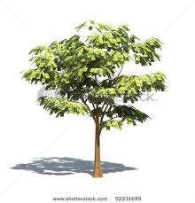 | 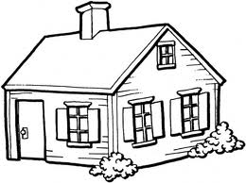
A picture of a tree | A picture of a house
 | 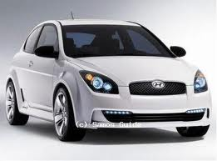
A picture of a table | A picture of a car

Exercise
- What do we call the drawing of an object as seen from aside?
- Draw a picture of a pot and a chair.

WEEK:1 Lesson 4 &5
1. What is a map?
A map is a drawing of an object as seen above.
A map is representation of an object as seen from above.

2. Examples of maps:

A map of a house | A map of a tree
A map of a table | A map of a pot
A map of a basket | A map of a hut
A map of a car | A map of a cup

3. Similarities between a map and a picture
- Both are drawings of objects.
- Both represent real objects.

4. Differences between a map and a picture
- A map is drawn as seen from above while a picture is drawn as seen from above.
- A picture is more detailed than a map.

Exercise
- How is a map similar to a picture?
- State one difference between a picture and a map.

WEEK:2 Lesson 6 &7
MAP READING;
- Maps help us to show different places.
- Maps can be of:
- Our school
- Our home
- Our village
- Our sub county
- Our district
- Our country etc

Elements of a good map
A good map should have the following qualities;
- A key
- A heading / title
- A compass rose/ compass direction
- A scale
- A frame/boundary.

Importance of each element to a map reader

(a) Heading / title;
- Shows what the map is all about.
- Without a title, a map reader will not know what the map is all about.

(b)Compass rose;
- Shows direction of places on a map.
- Without a compass rose, a map reader will not be able to tell the direction of places on a map.
(c)Frame;
- This beautifies the map.

(d)A scale;
- Shows the distance of places on a map.
- It is used to measure or calculate the distance between places on a map.

(e)A key;
- It is used to interpret symbols and colours used on a map.
- Without a key, a map reader will not be able to interpret symbols and colours used on a map.

Exercise
- Of what use is a compass rose to a map reader?
- Identify any other four elements of a good map.
- Which map element interprets map symbols?

WEEK:3 Lesson 1
DIRECTION
- What is direction?
Direction is a position in which a person is standing, moving or facing.
2. We can tell direction of places using an instrument called a compass.
3. A compass rose is an element of a map that shows direction of places on a map.

4. A compass has got points which show directions.

5. A compass has four major (primary) points called cardinal points namely;
- North(N)
- South(S)
- East(E)
- West.(W)
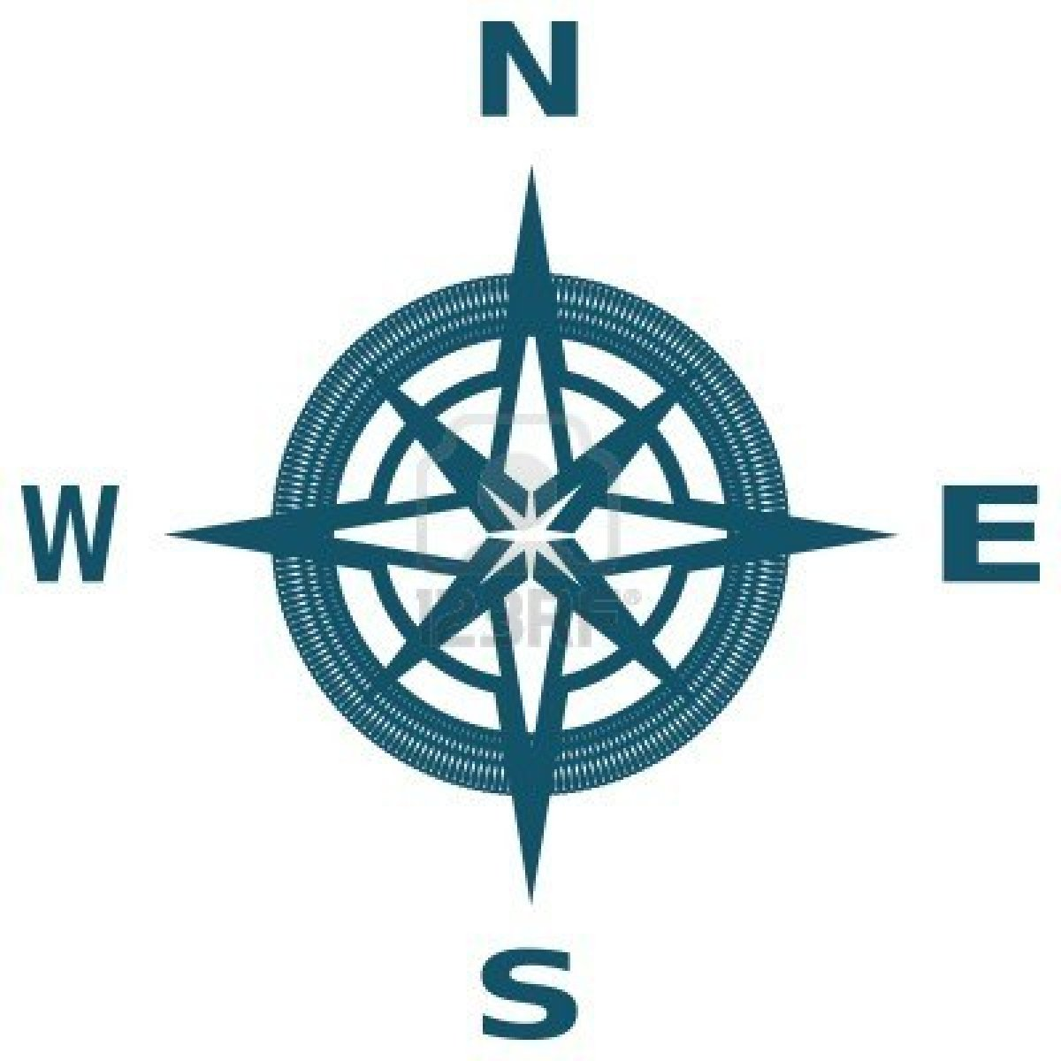
Exercise
- How is the use of a compass similar to that of a compass rose?
- What general name is given to the four major points of a compass?
3. How is a compass different from a compass rose?

WEEK:3 Lesson 2 &3
1. The next four (secondary) points are called semi-cardinal points namely;
- North East(NE)
- South East(SE)
- North West(NW)
- South West(SW)
N

NW NE

W E

SW SW
S
2. A compass needle rests in the true North.
3. The sun rises from the East and sets in the West.

4. People who use a compass to do their daily work

- rally drivers
- captains
- sailors
- tourists
- scouts and guides
- soldiers
- mountain climbers

5. Other ways of telling directions without using a compass include the following:-

- Using the sun
- Using shadows

6. A shadow is shortest at noon (midday) and longest in the morning and evening.

Exercise
- Name any two semi- cardinal points.
- In which direction does the sun set?
- Mention any two groups of people who need a compass in their work
- What else can Mutoto use to tell direction without using a compass?

WEEK:3 Lesson 4&5
SYMBOLS ON A MAP

1. What are map symbols?
Map symbols are small drawings used on a map to stand for real objects or features.

2. Reasons why symbols are used on maps
- They avoid overcrowding on a map.
- They represent real objects on a map.
3. Examples of map symbols

A symbol of a hill | A symbol of a lake
A symbol of a dam | A symbol of river
A symbol of a swamp | A symbol of a forest
A symbol of a water fall | A symbol of quarry
A symbol of a railway line | A symbol of a mountain
A symbol of mountain peak | A symbol of a factory
A symbol of a church | A symbol of an airport
A symbol of a bridge | A symbol of a plateau
A symbol of a bridge | A symbol of a school

Exercise
- What do we call the small drawings that stand for features on a map?
- Why are symbols used on a map?
- Draw and name any two map symbols you know.

WEEK:3 Lesson 6
TOPICAL TEST
1. What is the difference between map and a picture?
2. Mention two elements of a good map.
3. How is a key useful to a map reader?
4. What are map symbols?
5. Why are symbols used on a map?
6. Draw the map symbols for the following features.
a) A dam
B) A forest
c ) A quarry
7. Name the instrument used by a pilot to detect direction of places.
8. From which direction does the sun rise?
9. What general name is given to the four major points of a compass?
10 What problem will Richard face in reading a map without a compass rose?
11. How many divisions make up Kampala district?
12. Name the division which neighbours Makindye in the west.

WEEK:3 Lesson 7
PHYSICAL FEATURES OF OUR DIVISION

  - What are physical features?
These are natural landforms that give land shape
Physical features are also called landforms.

2. What are landforms?
Landforms are natural features that give land shape.

3. Examples of physical features include the following:-

- hills
- mountains
- valleys
- plains
- lakes
- streams
- rivers
- islands
- oceans
- seas
- water falls

- rift valleys

4. Examples of physical features found in our division:
- Hills
- Valleys
- A Lake
- Plateaus

Exercise
1. What do we call the natural landforms in an area?
2. Name any three landforms.
3. What physical feature is surrounded by water?

WEEK:4 Lesson 1
LAKES AND RIVERS

- What is a lake?
A lake is a large water body in a basin.
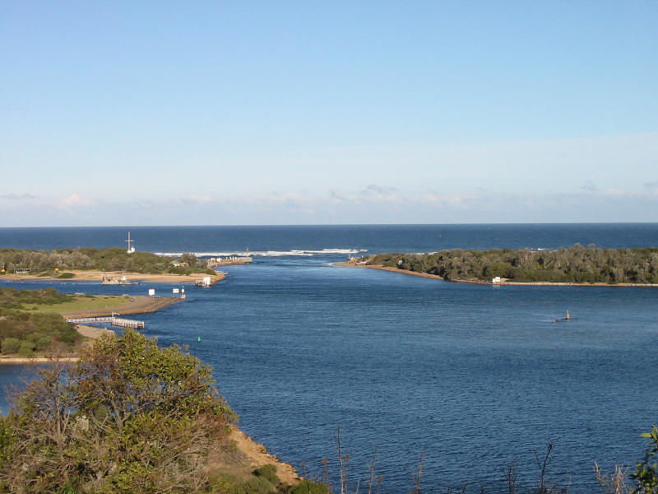
- Examples of lakes in Kampala include the following:-
  - Lake Victoria (Natural-lake)
  - Kabaka’s lake (human-made lake)

- What is a river?
A river is a narrow and long flowing water body.
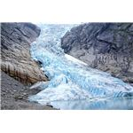
4. Rivers flow from a higher level to a lower level.

NB: There are no rivers in our division.

Importance of lakes and rivers to people
- They are used for water transport.
- People get clay, stones and sand used for building.
- Lakes and rivers provide fish and water to people.
- Rivers help in generating hydro electricity.
- They attract tourists.
- Lakes help in formation of rainfall.

Exercise
1. Name the man-made lake is found in Kampala district.
2. Which water body flows from a high level to a low level?
3. Why do some people like staying near lakes and rivers?

WEEK:3 Lesson 2&3
PLATEAU

1. What is a plateau?
A plateau is a raised flat topped piece of land.
A plateau is a table land

2. Importance of the plateau to people
- People build houses on the plateau.
- People grow crops on the plateau.
- People graze animals on the plateau.
- Roads, railways and airports are built on plateaus.

HILLS
1. What is hill?
A hill is a slightly raised piece of land.

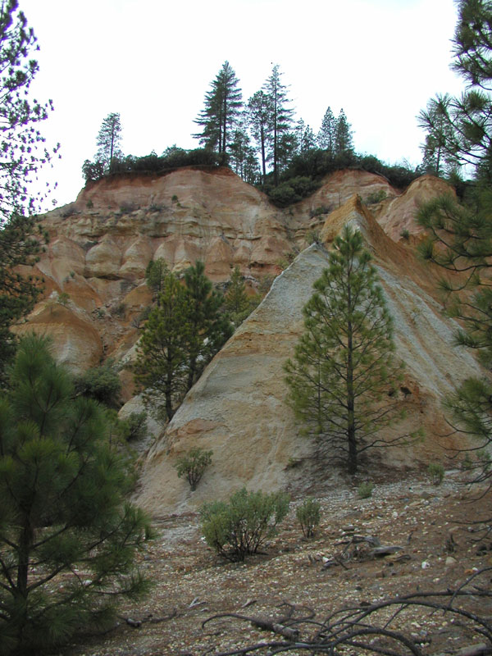

- Examples of hills in Makindye division:

- Kibuli hill
- Namuwogo hill
- Muyenga hill
- Nsambya hill
- Bukasa hill

- Importance of hills to people
- People settle on hills.
- They grow crops on hill slopes
- People graze their animals on hills
- Hills help in the formation of rainfall.
- People build masts on hills.

Exercise
- Define a plateau.
- State two uses of hills to people in Kampala
- Name any two hills in Makindye division.

WEEK:4 Lesson 4&5
IMPORTANT FEATURES ON MAJOR HILLS OF KAMPALA

S/N | Hill | Major features
1 | Muyenga hill | - Muyenga water tanks  - Hotel diplomatte  - Hotel International
2. | Kibuli hill | - Kibuli mosque  - Green hill Academy  - Islamic University, Kibuli  - Police training school.
3. | Nsambya hill | - Nsambya hospital  - Nsambya babies home  - Nsambya Sharing hall
 | Kololo hill | - Hotel Africana  - Kololo Airstrip  - Kololo hospital
5. | Nakasero hill | - Parliament building  - Radio Uganda  - UBC  - Nakasero State house  - Bank of Uganda.  - All saints church  - Christ the king church.
 | Rubaga hill | - Rubaga cathedral  - Rubaga hospital
 | Namirembe/  Mengo hill | - Namirembe cathedral  - Mengo hospital  - Mengo hospital  - Kabaka’s palace  - Sanyu babies home  - CBS radio
 | Mulago hill | - Mulago hospital  - Mulago school of nursing  - Synagogue church
 | Makerere hill | - Makerere University  - Makerere College  - University hospital

Exercise
- On which hill is your school found?
- Name any one feature found on each these hills.
- Makerere hill
- Kasubi hill
- Muyenga hill

WEEK:4 Lesson 6&7
VALLEYS
1. What is a valley?
A valley is lowland between two or more hills or mountains.

2. A picture of a valley

3. Examples of valleys in Kampala:
- Nakivubo valley
- Kitante valley
- Bat valley
- Lugogo valley
- Makenzi valley
- Kiwunya valley
- Green valley
- Katanga valley

4. Importance of valleys to people:
- People get water from valleys.
- Valleys are used for growing crops.
- People settle in valleys.

5. Why is it not good for people to settle in valleys?
- They flood during the wet season.
- Valleys are breeding places for vectors like mosquitoes.
- There is poor communication network.
- There are landslides in valleys.

Exercise
- Define a valley.
- Name any two valleys in Kampala.
- Write two problems faced by people staying in valleys.

WEEK 5 Lesson 1
TOPICAL TEST
- What are physical features?
- Identify any four landforms that are in Makindye division.
- State any three landforms that are not in Kampala district.
- Which people-made lake is found in Rubaga division?
- State any two use of each of these physical features.
- Lakes and rivers
- Hills and plateaus
- Valleys
6. Name the natural lake in Makindye division.
7. Identify any important feature found on each of these hills.
- Kololo hill
- Mulago hill
- Kasubi hill
8. How useful is Muyenga hill to the people of Kampala?
9. What term is used to mean each of the following?
- A raised flat-topped area.
- A lowland between two or more hills or mountains
10. Mention any two dangers of physical features

WEEK:5 Lesson 2
PEOPLE IN OUR SUB-COUNTY
  - What is an ethnic group?
An ethnic group is a group of people with the same origin speaking related languages.
-An ethnic group is also called a tribal group.
2. What is a tribe?
A tribe is a group of people with the same origin, customs and language.
3. What is a clan?
A clan is a group of people under one fore -father. (ancestor)
4. Examples of ethnic groups and their origins in our division

- Bantu
- Nilotics
- Nilo-hamites
- Hamites

- Bantu is the largest ethnic group in our division

Exercise
- What is a tribal group?
- What do we call a group of people under one forefather?
- Name the biggest ethnic group in Makindye division.
- To which ethnic group do you belong?

WEEK:5 Lesson3&4
Tribes and languages in each ethnic group;

Ethnic group | Tribe | Language
1.Bantu | Baganda  Basoga,  Banyankole  Bakiga,  Banyoro  Batoro,  Bagisu,  Bagwere,  Basamia  Baruuli. | Luganda  Lusoga  Runyankole  Rukiga  Runyoro  Rutoro  Lugisu  Rugwere  Samia  Luruuli
2. Nilo-Hamites | Karimojong  Iteso  Sabiny.  Kumam  Langi | Akarimojong  Ateso  Kupsabiny  Kumam  Langi
3.Nilotics | Acholi  Lugbara  Jaluo  Japadhola | Acholi  Lugbara  Luo  Adhola
4. Hamites | Bahima  Batutsi  Bahororo | Runyankole  Kinyarwanda  Runyankole
Exercise
- what is your tribe?
- Name two Bantu tribes you know.
- Which language is spoken by the Acholi.

WEEK:5 Lesson 5
TOPICAL TEST
- What term is used to mean each of the following?
- A group of people of the same origin speaking related languages.
- A group of people of the same language and customs.
- A group of people living together related by blood or marriage.
- Identify four ethnic groups in Makindye division.
- Under which ethnic group do the Karimojongs belong?
- Give any three Bantu tribes in Kampala district.
- Which language is spoken by each of these tribes?
- The Baganda
- The Iteso
- Name the largest ethnic group in our division.
- How are the Basoga and Banyankole similar?

WEEK:5 Lesson 6&7
LEADERS IN SUB-COUNTY

1. Who is a leader?
A leader is a person who guides and manages others.

Duties of a leader
- Encourages others to work hard.
- Supervises others
- Teaches others their responsibilities.
- Settles disputes
- Maintains peace.
Types of leaders in our sub-county
  - Religious leaders
  - Political leaders
  - Cultural leaders
  - Civic leaders

1. Examples of religious leaders include the following.

- Pastors
- Priests
- Sheikhs
- Bishops
- Imams
- Evangelists
- Reverend

2. The roles of religious leaders
- They teach people the word of God.
- The guide and counsel us.
- They help the needy people like; orphans, widows and the blind

Exercise
- Who is a leader?
- State any one role of each of these leaders.
  - a pastor
  - an Imam
- Mention any two leaders in a church.

WEEK:6 Lesson1&2
1. Examples of cultural leaders
- kings
- clan leaders
- chiefs
2. Tribes in Uganda and their kings
Tribe | Title | Name
Baganda | Kabaka | Ronald Muwenda Mutebi
Ankole | Omugabe | -
Banyoro | Omukama | Solomon Gafabusa
Toro | Omukama | Oyo Nyimba Kabamba Igura iv
Basoga | Kyabazinga | -
Iteso | Emorimor | Papa Osuban Adugala
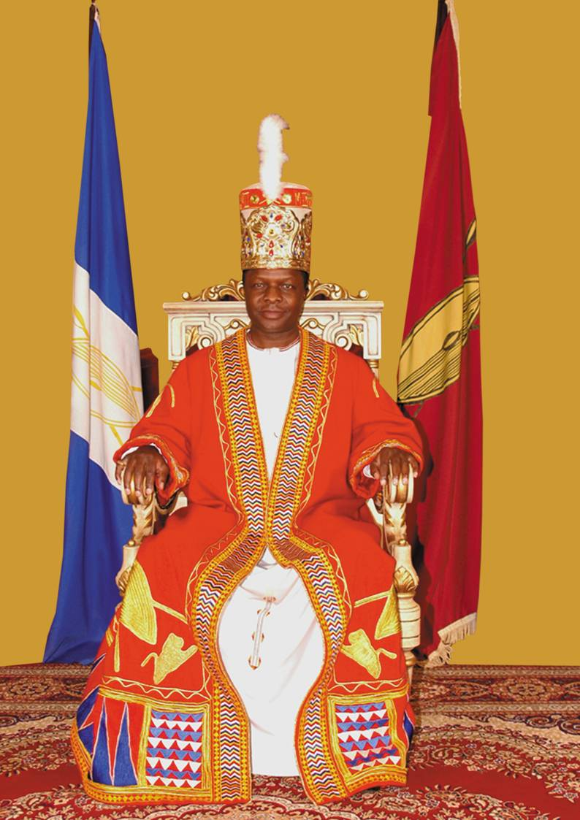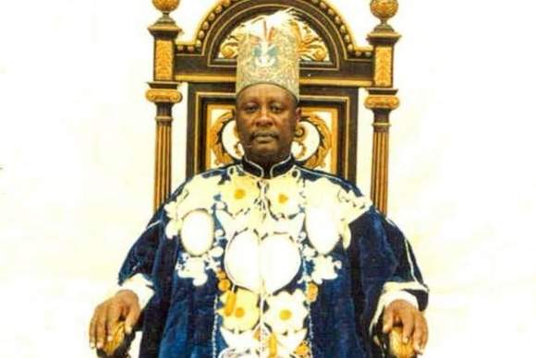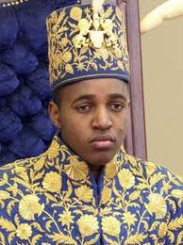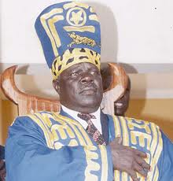
Kabaka Ronald Omukama Solomon Omukama Oyo Papa Osuban
Mutebi Gafabusa Kabamba Adugala
Duties of cultural leaders
- They promote culture.
- They unite people.
- They help to develop their areas.
3. Examples of civic leaders
- DEO
- CAO
- DDHS

Exercise
- Who is the current king of Buganda kingdom?
- Which title is given to the king of Toro?
- Which tribe is rule by an Emorimor?
- State one role of a king king.

WEEK:6 Lesson3
1. Political leaders include the following
- Local council 1
- Local council 2
- Local council 3
- Local council 4/MP
- Local council 5
- Mayor
2. The local council committee is headed by the Chairperson.
3. The local council committee is made up of ten members.
Duties of the local council;
- To keep law and order
- To organize meetings
- To settle disputes

Exercise
- Who is the political head of;
- A village?
- A country?
- How many members make up the LC 1 committee?
- What is the role of the LC in an area?

WEEK:6 Lesson 4&5
Members of local council and their responsibilities;
1. Chair person;
- Chairs meetings
-Heads the local council
-Signs official documents
2. Vice chair person;
-Assist the chairman
-In charge of children’s affairs.
3. The general secretary;
-records minutes
-keeps records
4) Secretary of finance; -calls the executive meeting
5) Secretary for security
6) Secretary for information, education and mobilization
7) Secretary for youth and education
8) Secretary for women and public affairs
9) Secretary for the disabled.
10) Secretary for production and environmental protection
The mayor of Makindye division is Dr.Ian Clarke.

Exercise
- Who chairs council meetings?
- Mention two other members of the LC 1 committee.

WEEK:6 Lesson 6
TOPICAL TEST
- Identify three types of leaders in your area.
- Mention two leaders in a church?
- Who is the current Lord Mayor of Kampala district?
- Write the title given to the kings of the following kingdoms.
- Buganda
- Ankole
- How many members make up the LC 1 executive committee?
6. Why should a village have a Local Council?
7. Who heads the Local Council?
8. Which LC member is in-charge of the following?
- Children’s affairs
- Women’s affairs
- Security
9. Why should we have the LC in our areas?

WEEK:6 Lesson 7&1
THEME 2: LIVELIHOOD IN OUR SUB-COUNTY

OCCUPATIONS OF PEOPLE IN OUR DIVISION

1. What is an economic activity?
An economic activity is any work done by people to get money.

2. People in our areas have different economic activities namely:

- brick making/laying
- fishing
- mining
- pottery
- nursing
- welding
- tailoring
- teaching
- hair cutting
- cattle keeping
- weaving
- carpentry
- car washing
- road construction
- building
- craft making
- farming;

- trade

3. Define these terms;
- Trade: Is the buying and selling of goods.
- Farming :This is the growing of crops and keeping /rearing of animals
- Crafts: Are things made by hands from local materials.eg.
  - balls
  - doormats
  - ropes
  - baskets
  - necklaces

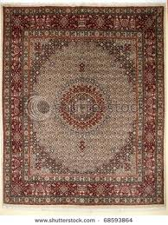 | 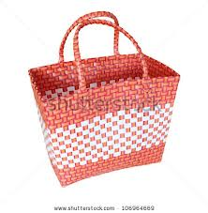 | 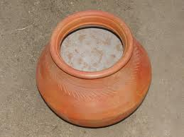
a doormat | a basket | a pot

4. The main economic activity of most people in villages is farming.
5. The main economic activity carried out near lakes and rivers is fishing.

Exercise
- What do we call work done by people to get money?
- Give four examples of such activities.
- What is the main economic activity of most people in villages.

WEEK:7 Lesson 2
TOPICAL TEST
- What is an economic activity?
- State any four economic activities of people in your division.
- What is the major economic activity around lakes?
- Write the meaning of the words
- Farming
- Trade
- Crafts
- Which other term can be used to mean economic activity?
- Who is a farmer?
- Name any products produced by these people.
- A farmer
- A tailor
- A carpenter

WEEK:7 Lesson 3 &4
SOCIAL SERVICES IN OUR SUB-COUNTY

1. What are social services?
Social services are services provided by the government to make people’s lives better.

2. Examples of social services.
- education
- health
- housing
- banking
- security
- communication services
- transport
- water supply

EDUCATION SERVICE
1. Education service is provided by the following people
- teachers
- lecturers
- professors
- tutors

2. Importance of education
- To learn how to read and write.
- To get jobs.
- To learn how to count.
- People learn how to prevent diseases.

Exercise
- What are social services?
- List two social services in your area.
- Why should people go to school?

WEEK:7 Lesson 5
Important officials in education service
1. The District Director of Education (DDE) heads all schools in a district.

NB. All schools in Uganda are under the Ministry of Education and Sports. (MOES)

2. The Minister for Education and Sports is Hon. Jessica Alupo.

3. The state Minister for Primary Education is Hon Kamanda Bataringaya.

- The Minister for Education in charge of Sports is Hon. Charles Bakabulindi.

Exercise
- Who heads all schools in a district?
- Write MOES in full.
- Who is the current minister for education and sports?

WEEK:7 Lesson6& 7
WATER SUPPLY
1. People who provide water services are called plumbers.
2. The body responsible for supplying piped water in our country is NWSC.

3. NWSC in full is National Water and Sewerage Corporation.

SECURITY SERVICE
1. Security means having peace in an area.

2. People who provide security service in our sub-county include;
- The army
- Police
- Local Defence Units(LDUs)
- Local Councils(LC)
- Private security guards

3. How do the above organs keep security?
- The army; Fights all people who attack us with guns.
- It defends the country from external attacks like rebels.
- The police; Keeps law and order.
- The LDUs; Works with the police to arrest wrong doers.
- The prison force; Keeps wrong doers out of good people.
- The LCs; Keep law and order in communities like in villages.

4. Why are wrong doers kept in prisons?
- To reform (change) into good people.
- To stop them from committing more crimes.
- To separate / isolate them from good people/citizens.

5. How do the police keep law and order?
- By arresting wrong doers.
- By keeping wrong doers in cells before they are taken to court.
- By controlling traffic on roads.
- By investigating crimes.

Exercise
- Name any two groups of people who provide security to us.
- How does the police keep law and order?
- Why are wrong doers taken to prisons?

WEEK:8Lesson 1
TRANSPORT SERVICE
1. What is transport?
Transport is the movement of people and goods from one place to another.
2. Types of transport
- Road transport
- Water transport
- Air transport
- Railway transport.

3. Means used in road transport

- cars
- lorries
- bicycles
- tricycles
- motorcycles
- buses
- omnibuses
- wheelbarrows
- animals like donkeys, horses, oxen, camels.
- walking or running

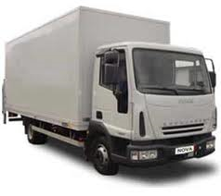 | 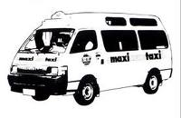 | 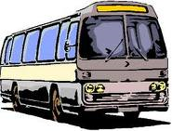
Lorry | Taxis | Buses / vans
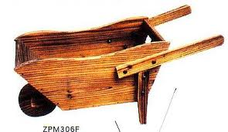 | 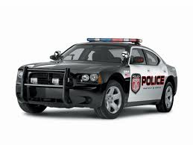 | 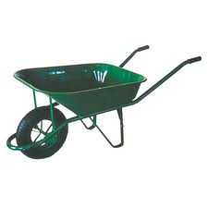
cart | cars | Wheel barrow

Exercise
- Define the term transport
- Mention two types of transport used in your division
- Draw, name and colour any two means of road transport

WEEK:8 Lesson 2
1. Advantages of road transport
- It is very common.
- It is cheap to construct roads.
- It has many means of transport.

2. Disadvantages of road transport
- Accidents are very common.
- Roads in towns have a lot of traffic jam.
- Marrum roads are slippery in the wet season and dusty in dry seasons.

Exercise
- What is the commonest type of transport used in Makindye.
- Why is road transport used by most people in your division?
- State any one disadvantage of road transport.

WEEK:8 Lesson 3&4

WATER TRANSPORT
1. Means used in water transport
- boats
- ships
- ferries
- sub-marines
- canoes
- yachts
- rafts

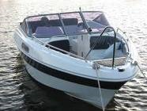 | 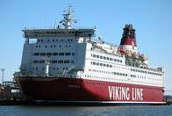 | 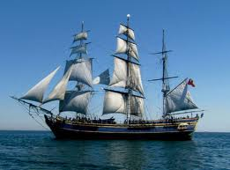
boat | ferry | ship

2. Advantages of water transport
- It is the cheapest type of transport.
- It is the best type of transport for carrying bulky and fragile goods.
- It is not affected by traffic jam.

3. Disadvantages of water transport
- It is very slow and so it cannot be used to carry perishable goods.
- Water accidents are always fatal (deadly).
- It can be affected by bad weather.

Exercise
- Which type of transport is the best for carrying bulky goods?
- Why is water transport not good for carrying perishable goods?
- Draw, name and colour any two means used on water transport

WEEK:8 Lesson 5
AIR TRANSPORT
1. Means used in air transport
  - aero planes
  - air balloons
  - rockets
  - parachutes
  - air-ship
  - helicopters

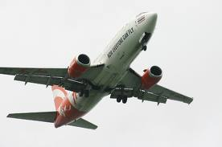 | 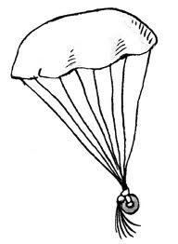  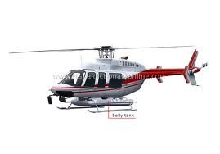 |  | 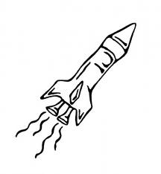
Aero plane | parachute | helicopter | rocket

2. An aeroplane is the fastest means of transport used in Uganda.

3. The fastest type of transport used for long distances is Air transport.

4. Entebbe Airport is the only international airport in Uganda.

- It is found in Wakiso district.

Exercise
- Name the fastest means of transport used for long distances?
- Where do we find the international airport in Uganda?
- Draw, name and colour any two means of air transport

WEEK:8 Lesson 6
1. Advantages of Air transport
- It is the fastest type of transport.
- It is the best for carrying perishable goods.
- It is very comfortable.
- It is not affected by jam.

2. Disadvantages of air transport
  - It is very expensive
  - It is affected by bad weather.
  - It is not common in many places.

Exercise
- Why is air transport the best for carrying perishable goods?
- Give one reason why air transport is used by few people.

WEEK:8 Lesson 7
RAILWAY TRANSPORT

1. Means used in railway transport
- Trains

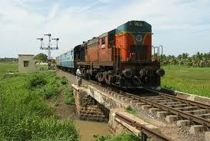
A train

2. Advantages of railway transport
- It can be used for carrying bulky goods.
- It is cheaper than road and air.
- It’s not affected by traffic jam.
3. Disadvantages of railway transport
- It is very expensive to construct railway line.
- It is not common in many places.
- It is very slow.

4. Importance of transport
Transport is good because:-
- It helps people to move from one place to another.
- It makes trade easy.
- It helps to carry goods.

Exercise
- How is railway transport better than road transport?
- Which means of transport is used on railway lines?
- Why is railway transport not good for carrying perishable goods?

WEEK:9Lesson 1
COMMUNICATION
1. What is communication?
Communication is the sending and receiving of messages.

2. Means of communication
Communication means can be grouped into traditional (local) and modern means.

- Traditional means of communication include:
  - drums
  - whistles
  - horns
  - bells
  - gestures
  - smoke/fire

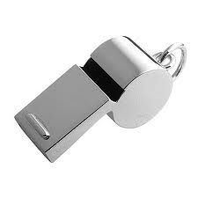  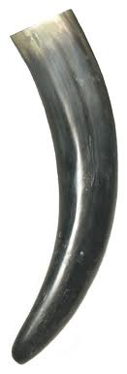 | 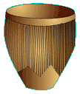
A whistle |  | A horn

3. Draw and name any two local means of communication

Exercise
- What do we call the sending and receiving of messages?
- Mention two places where whistles are used for communication.
- Draw, name and colour any three local means of communication.

WEEK:8 Lesson 2
1. Modern means of communication include;

- telephones
- newspapers
- televisions
- telexes
- telegrams
- computers
- radios
- letters

  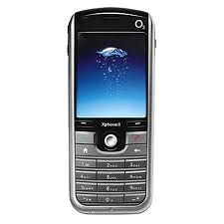 |  | 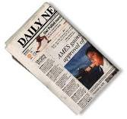  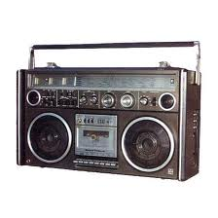
A television | A telephone | A radio | Newspapers

Exercise
- Give two uses of a radio to people.
- How can televisions be a problem to people?
- Why are there few people who use computers?
- Draw, name, and colour any two modern means of communication.

WEEK:9 Lesson 3
MEDICAL SERVICE
1. We get medical services from.
  - hospitals
  - clinics
  - dispensaries
  - drug shops
  - pharmacies

2. People who provide medical service include:-
- doctors e.g. surgeons, dentist and opticians.
- nurses
- mid wives
- lab technicians / attendants.
- herbalists

3. The district Director of Health Services (DDSS) is in charge of medical services in the district.

4. Where do herbalists get there medicine?

They get them from plants.

5. What is the use of an ambulance?
- An ambulance carries sick people (patients) to hospital.
- It also carries casualties to hospital.

Exercise
- Name two groups of people who provide medical service.
- Where do people get treatment when they are sick?
- Which vehicle carries patients to hospital?

WEEK:9 Lesson 4
BANKING SERVICE
1. People who provide banking service
  - Bankers

3. Examples of banks include the following:-

- Bank of Uganda
- Stanbic bank
- Barclays bank
- D FCU bank
- Bank of Baroda
- Housing finance bank
- United Bank of Africa (UBA)
- Standard Chartered bank
- Crane bank
- Cairo bank
- Bank of Africa

4. Importance of banks
- They provide jobs.
- Banks provide loans to people.
- They keep important documents like land titles.
- They give provide foreign exchange services.

Exercise
- Write two examples of banks in your area.
- Apart from keeping money, give other two uses of banks.
- Which is the main bank in Uganda?
- Why do we keep our money in banks?

WEEK: 9 Lesson 5
- Problems faced in providing social services
- Lack of enough funds/money.
- Large population
- Corruption
- War/instability in some areas.
- Lack of skilled people.

- Possible solutions to the problems
- Borrowing money from other countries.
- Teaching people family planning methods.
- Building better roads.
- Building more hospitals and schools.
- Arresting corrupt officials.
Exercise
- State two problems the government faces in providing social services.
- How can these problems be solved?

WEEK:9 Lesson 6
TOPICAL TEST

- What are social services?
- Mention any two social services in your area.
- Which social service is needed for the following;
- To control death rate and spread of diseases.
(b)To enable the movement of people and goods
- Define these terms.
(a)Communication
(b)Transport
- Write two types of transport used by people.
6. Why are there few people who use air in our division?
7. Draw and name any two modern means of communication
8. How are banks important in your area?
9. Which police department is in charge of maintaining law and order on the road?
10. State any two problems faced by schools under the UPE program.

THE END

